StreamingApp
System Architecture & Deployment Documentation
MERN Microservices • Docker • Jenkins • Amazon ECR • Kubernetes • Helm

1. System Architecture
StreamingApp is a MERN-based application deployed as five application services. Jenkins builds Docker images and pushes them to Amazon ECR. Kubernetes, pulls the private ECR images and deploys them using Helm.
GitHub
│
▼
Jenkins CI/CD
│
├── Docker Build: Frontend
├── Docker Build: Auth
├── Docker Build: Streaming
├── Docker Build: Admin
└── Docker Build: Chat
│
▼
Amazon ECR (us-east-1)
│
▼
Kubernetes / Killercoda
│
├── Frontend :80
├── Auth :3001
├── Streaming :3002
├── Admin :3003
└── Chat :3004
│
▼
MongoDB

2. Application Architecture
Service | Technology | Port | Purpose
Frontend | React + Nginx | 80 | User interface
Auth | Node.js + Express | 3001 | Authentication and user operations
Streaming | Node.js + Express | 3002 | Video/streaming operations
Admin | Node.js + Express | 3003 | Administrative operations
Chat | Node.js + Express + Socket.IO | 3004 | Real-time chat
MongoDB | MongoDB | 27017 | Persistent application data

Deployment Steps
Phase 1: Version Control with Git
🔹 1.1 Fork the Repository
- Go to the main repo: https://github.com/UnpredictablePrashant/StreamingApp/
- Click Fork

🔹 1.2 Clone Fork Locally
git clone https://github.com/thupeshkumar/StreamingApp.git
cd StreamingApp
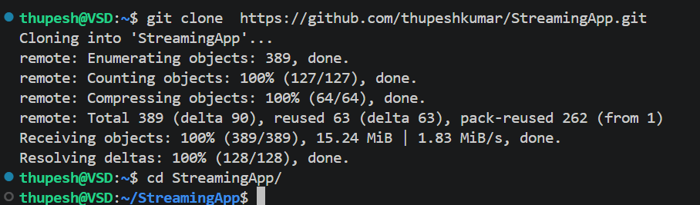

🔹 1.3 Add Upstream (BEST PRACTICE)
This keeps the fork updated with the original repo.
git remote add upstream https://github.com/UnpredictablePrashant/StreamingApp.git
git remote -v
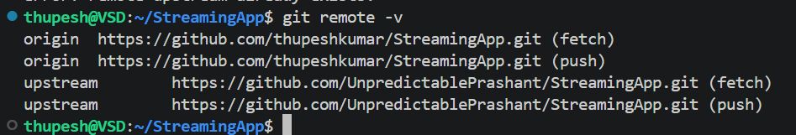

🔹 1.4 Sync Fork with Upstream
git fetch upstream
git checkout main # (if you are in other feature branch)
git merge upstream/main #if needed
git push origin main
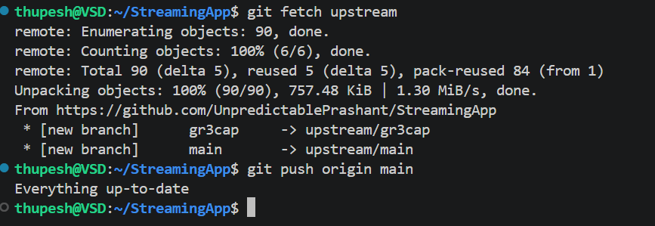
💡 DevOps Tip: Do this regularly
Never work directly on main. Use feature branches.

Phase 2: Prepare & Containerize MERN App
Project Tech Stack:
- Frontend → React
- Backend → Node.js/Express
- Database → MongoDB (likely external or containerized)
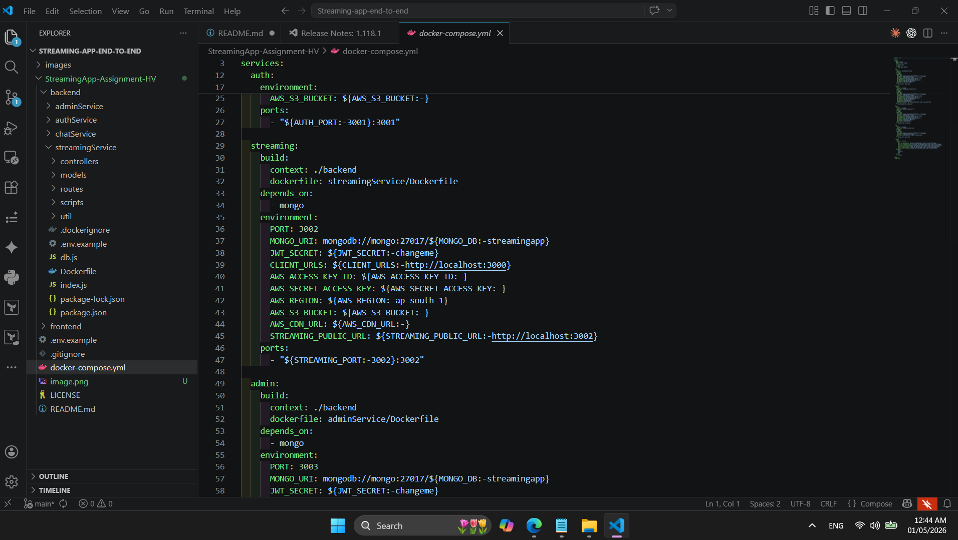

🔹 2.1 Dockerfiles
Inside /backend:
There are 4 microservices:
- adminService
- authService
- chatService
- streamingService
There must be separate Dockerfiles for each service with correct ports and endpoints.

Micro-Services Ports
Service | Port | Description
authService | 3001 | User authentication, registration, JWT issuance
streamingService | 3002 | Video catalogue, S3 playback endpoints, public APIs
adminService | 3003 | Dedicated admin microservice for asset management and uploads
chatService | 3004 | Websocket + REST chat for live watch parties
frontend | 3000 | React SPA with revamped UI and integrated chat
mongo | 27017 | Shared MongoDB instance
All backend services share common database models and utilities through backend/common.

Containerization
The repository contains Dockerfiles for all components:
- frontend/Dockerfile
- backend/authService/Dockerfile
- backend/streamingService/Dockerfile
- backend/adminService/Dockerfile
- backend/chatService/Dockerfile

🔹 2.2 Environment Variables Configuration
Created an .env for each service. All services accept the standard AWS credentials for S3 access.
Auth Service (backend/authService/.env)
PORT=3001
MONGO_URI=mongodb://localhost:27017/streamingapp
JWT_SECRET=changeme
CLIENT_URLS=http://localhost:3000
AWS_ACCESS_KEY_ID=
AWS_SECRET_ACCESS_KEY=
AWS_REGION=ap-south-1
AWS_S3_BUCKET=
I have set up .env for each backend microservice, like the above, with my configurations & secrets with a specified port.
🔹 2.3 Frontend Dockerfile
Inside /frontend:
I have created .env with the following endpoints:
REACT_APP_AUTH_API_URL=http://localhost:3001/api
REACT_APP_STREAMING_API_URL=http://localhost:3002/api
REACT_APP_STREAMING_PUBLIC_URL=http://localhost:3002
REACT_APP_ADMIN_API_URL=http://localhost:3003/api/admin
REACT_APP_CHAT_API_URL=http://localhost:3004/api/chat
REACT_APP_CHAT_SOCKET_URL=http://localhost:3004
Note: In frontend localhost can work, but in backend microservices, each should be communicated with the correct api so localhost will not work.
🔹 2.4 Test Locally with Docker
docker-compose up –build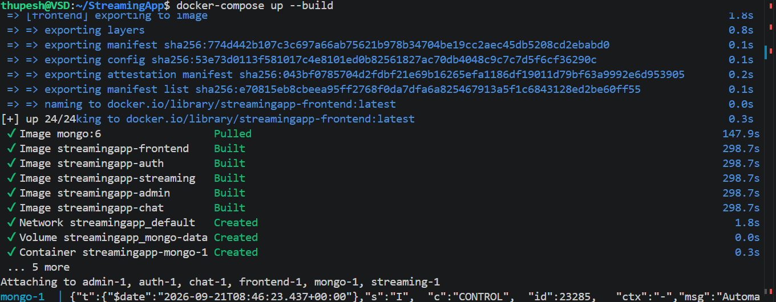
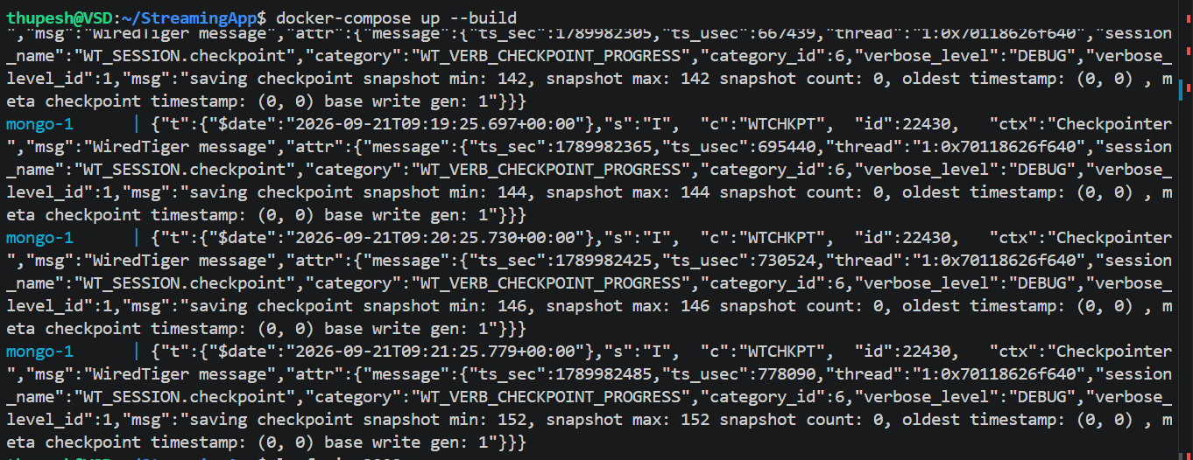
docker-compose will build the images and run all the containers by reading each & every Dockerfile inside the app folder

Access the App on port 3000/3005
http://localhost:3000 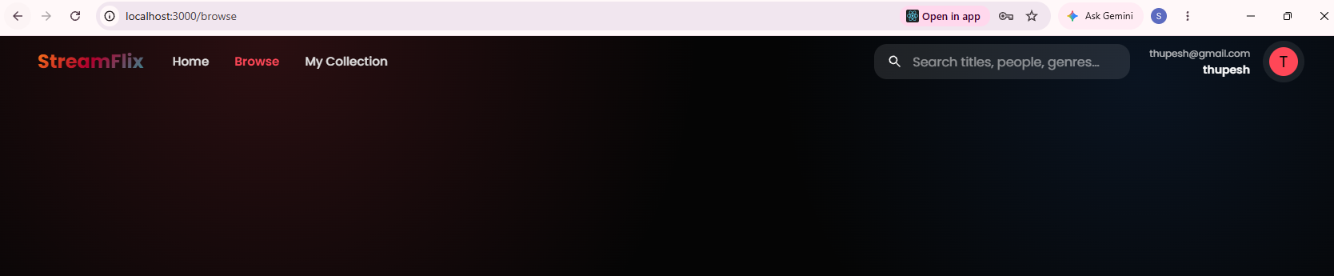
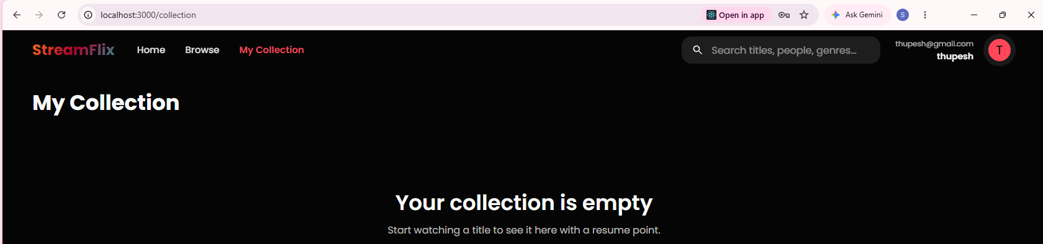
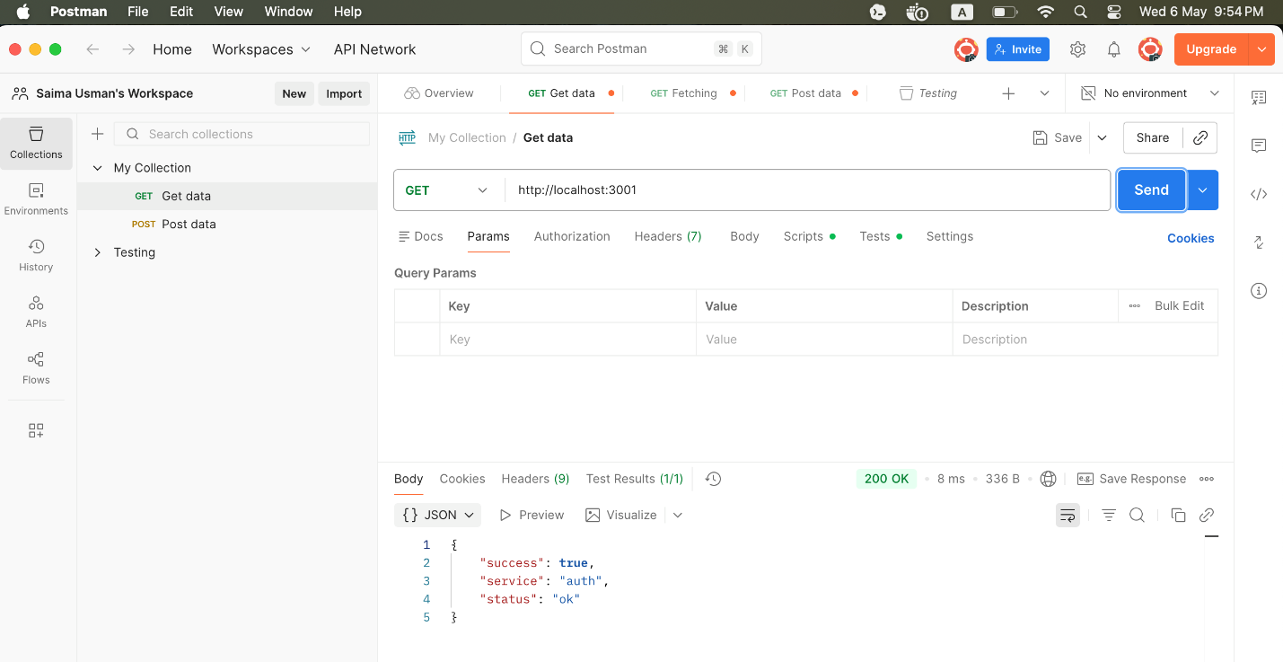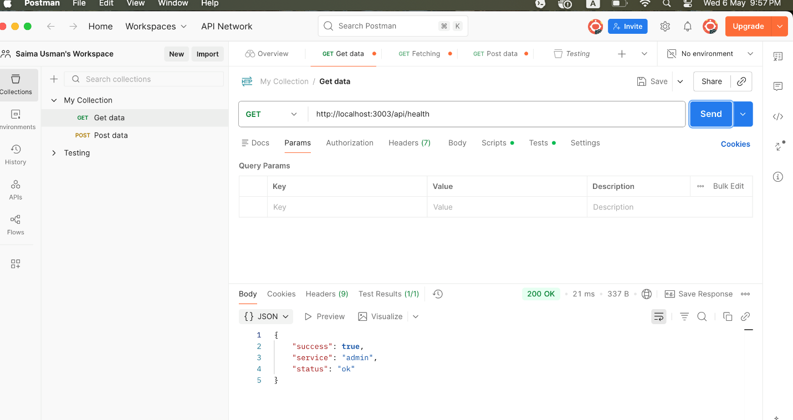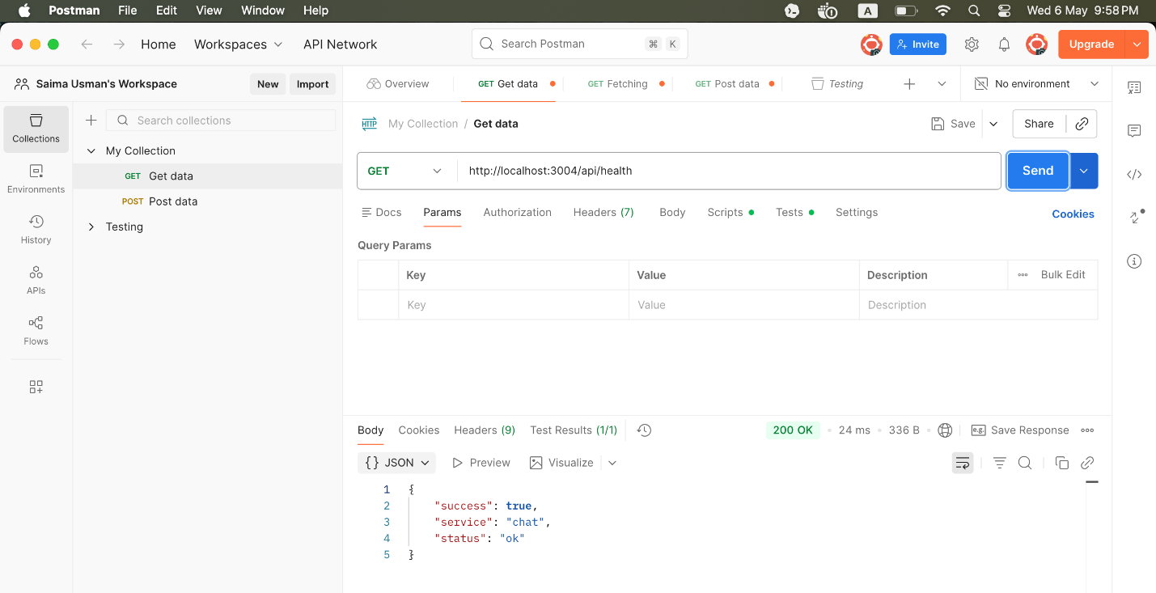

Troubleshooting:
Frontend Errors
Browser → F12 key → Console
Backend Errors
Check backend logs
docker-compose logs authservice
Check for:
❌ Mongo connection error
❌ Port already in use
❌ Missing env variables

Port is already allocated (0.0.0.0:3000)
Solution:
1. What is using port 3000
lsof -i :3000
Copy the process id (PID) and kill that process if the process is not necessary.
2. Kill the process
kill -9 <pid>

If it's an old container:
docker ps
- Copy the container id or name
- Stop the container and delete:
docker stop <container_id>
docker rm <container_id>

Build again after all changes:
docker-compose down
docker-compose up --build

Each Microservice should use the following format to communicate with mongodb, localhost will not work
MONGO_URI=mongodb://mongo:27017/streamingapp
After fixing everything:
- Containers started ✔️
- Backend connected to Mongo ✔️
- Frontend loaded properly ✔️
- APIs responded ✔️

✅ Expected Results:
- Frontend → http://localhost:3000
- Auth API → http://localhost:3001
- Streaming API → http://localhost:3002
Local Testing Done! 👍
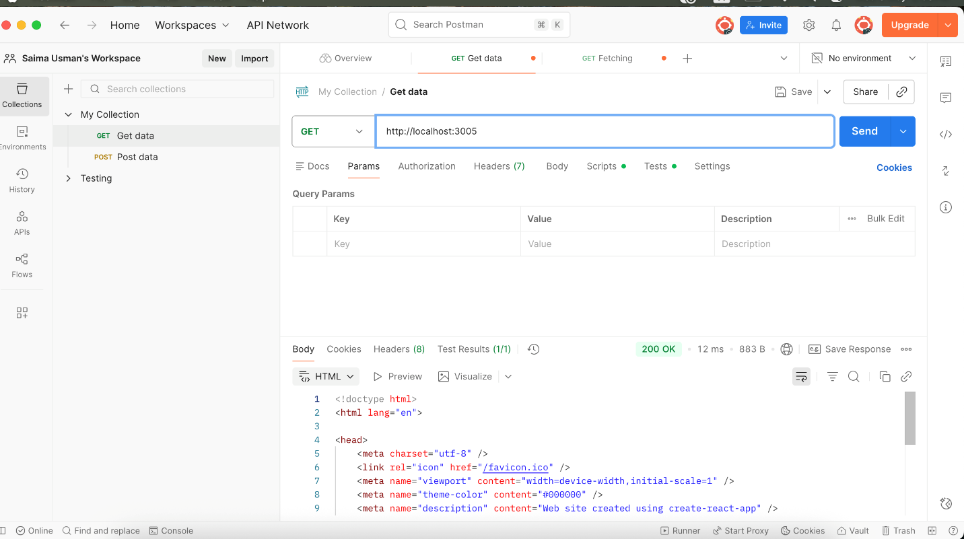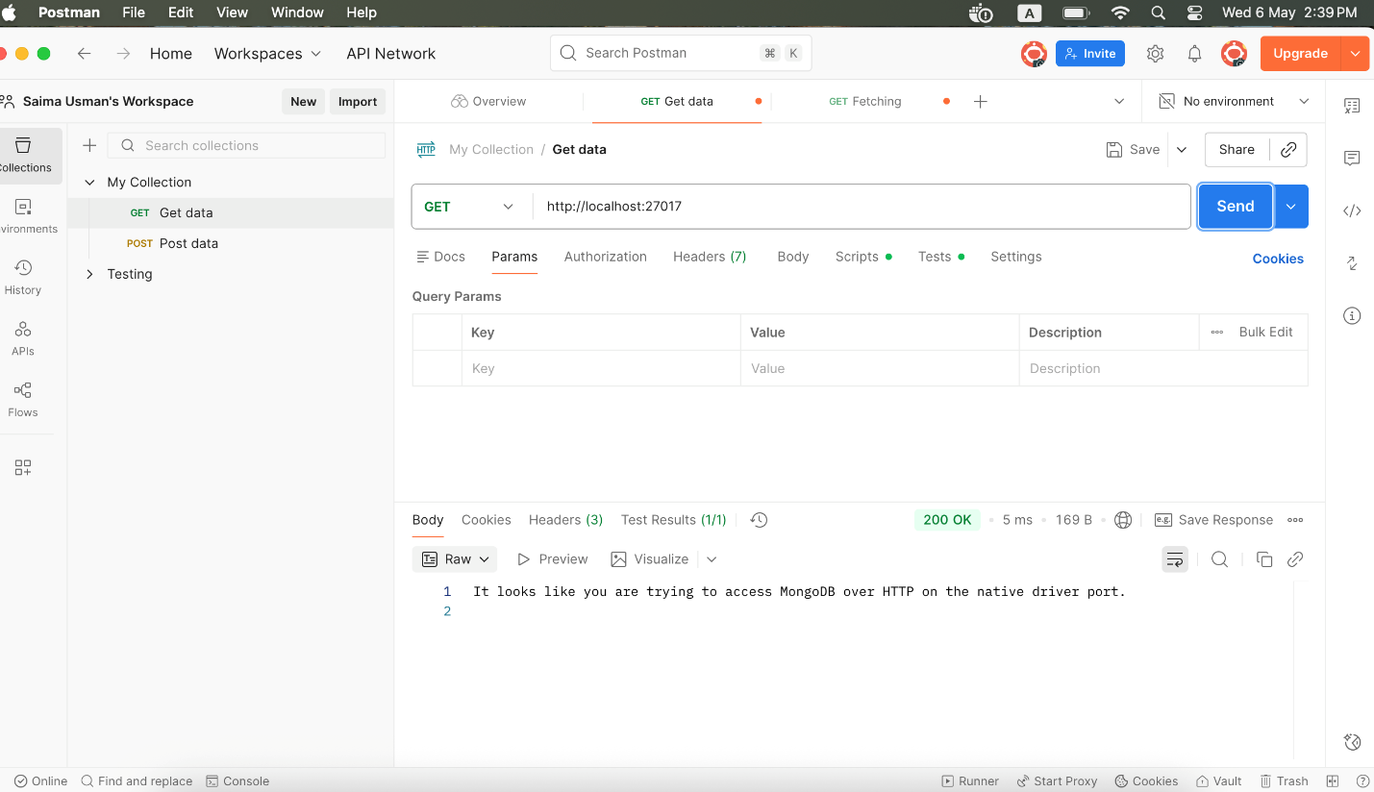
Removed the Resources after local Testing:

☁️ Phase 3: Install AWS CLI & Configure
aws configure
Enter:
- Access Key (Grab from AWS IAM User)
- Secret Key (Grab from AWS IAM User)
- Region (for eg: ap-south-1)

🔹 3.1 Build, Tag and push Docker images to ECR using Jenkins jobs
I have written some clean shell scripts to push ALL services to AWS ECR, which will be executed through Jenkins Jibs.
- scripts/create-ecr-repos.sh
- scripts/deploy-eks.sh
Make them executable
chmod +x create-ecr-repos.sh
chmod +x deploy-eks.sh
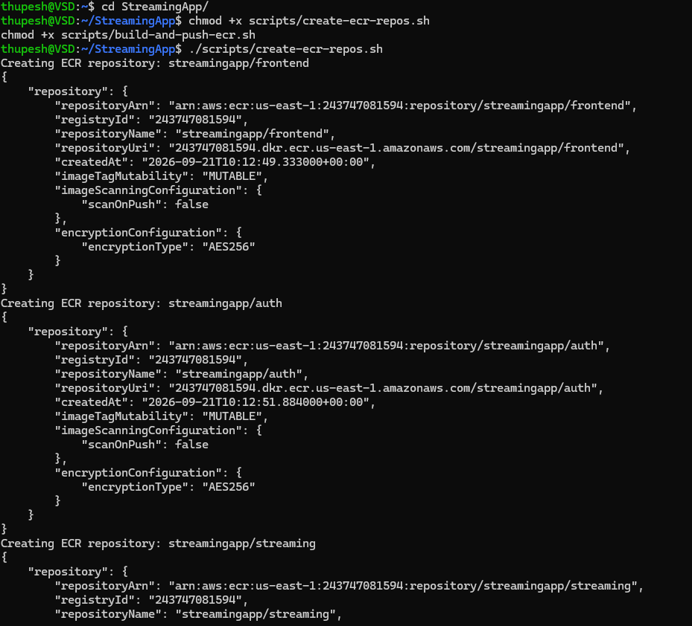

Every Changes were tested in staging branch before the final deployment
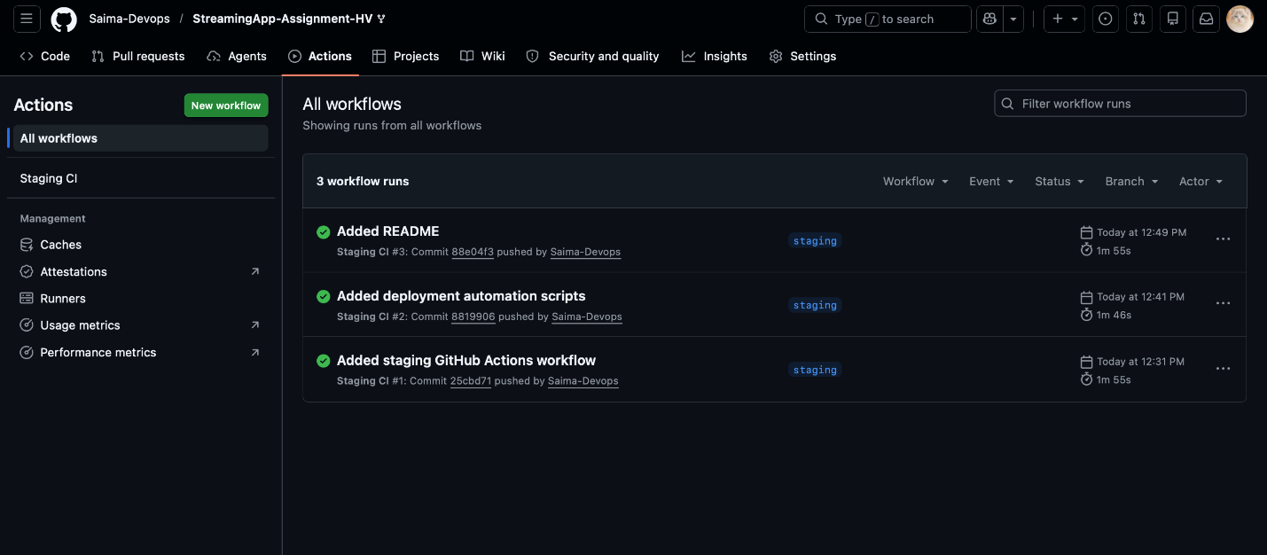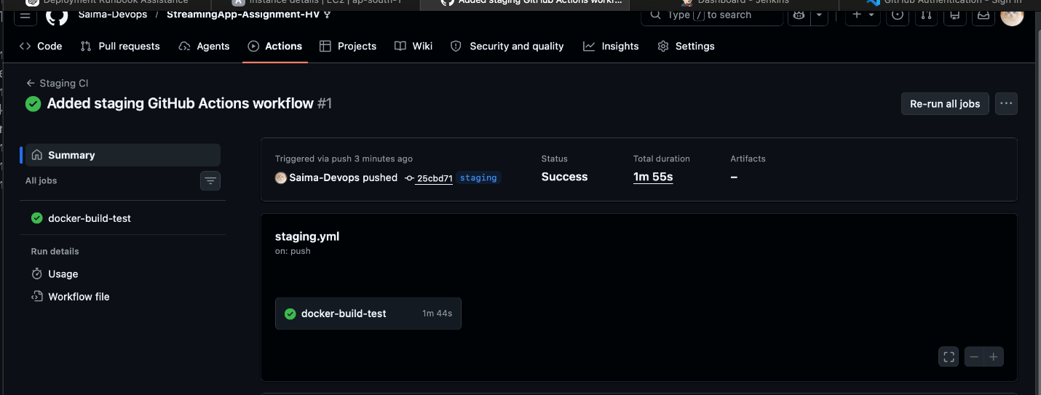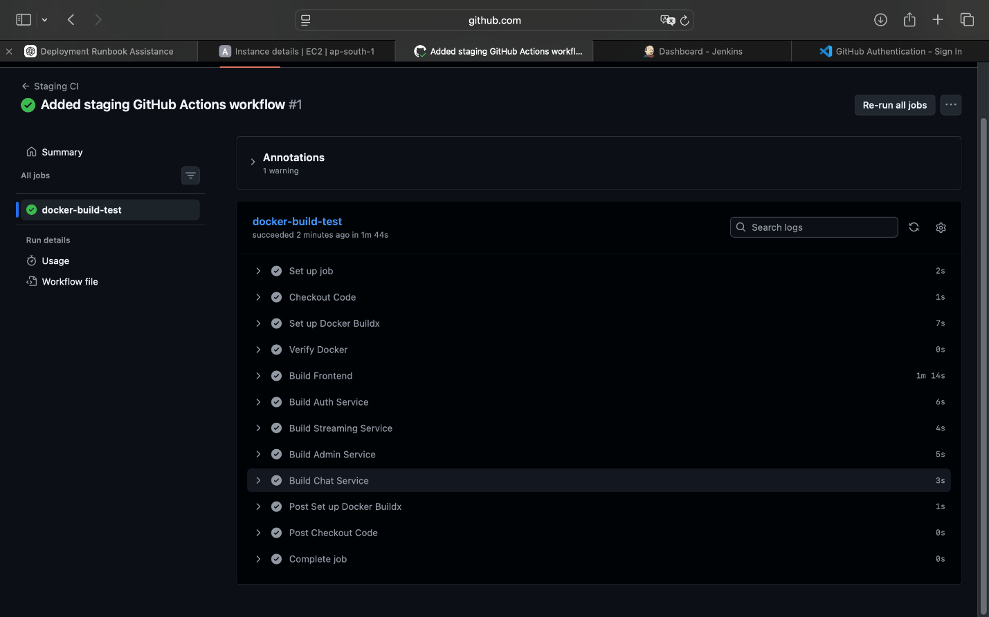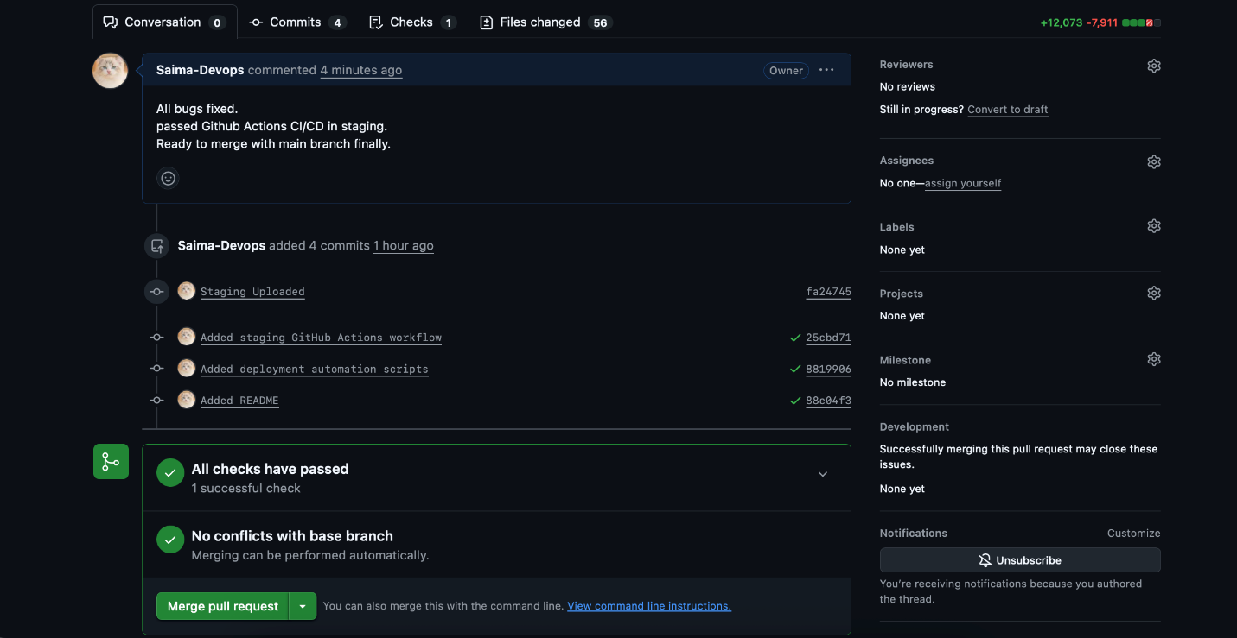

🔧 PHASE 4: Jenkins CI/CD
🔹 4.1 Install Jenkins on EC2 or any cloud-based Jenkins
- Install Jenkins on an EC2 instance that has Docker, AWS CLI, kubectl, and Helm installed.
sudo apt update
sudo apt install openjdk-17-jdk -y
wget -q -O - https://pkg.jenkins.io/debian/jenkins.io.key | sudo apt-key add -
sudo apt install jenkins -y

🔹 4.2 Install Jenkins Plugins
- Pipeline
- Git
- GitHub
- AWS Credentials
- Docker Pipeline
Verify:
aws --version
docker --version
kubectl version --client
helm version
eksctl version

🔹 4.3 Create Jenkins credentials:
- ID: aws-jenkins
- Type: AWS credentials
- Permissions: ECR push, EKS deploy, SNS publish if ChatOps is enabled

🔹 4.4 Jenkins Pipeline
- Created a Pipeline job from SCM pointing to the repo "https://github.com/Saima-Devops/StreamingApp-Assignment-HV.git.
- Jenkinsfile is present on the root.
- Configured a webhook in your Git repository so new commits trigger builds.
What does the pipeline do:
- Checks out code.
- Logs in to ECR.
- Creates missing ECR repositories.
- Builds and pushes all five images.
- Deploys to EKS from main.
- Publishes optional SNS success/failure messages if SNS_TOPIC_ARN is set.

🔹 4.5 Create AWS EKS Cluster
Configure AWS locally:
aws configure
export AWS_REGION=ap-south-1
export ECR_PREFIX=streamingapp
eksctl create cluster \
--name streamingapp \
--region "$AWS_REGION" \
--nodes 2 \
--node-type t2.medium \
--managed
Configure kubectl
aws eks update-kubeconfig --name streamingapp --region "$AWS_REGION"
kubectl get nodes
NOTE:
- Install the AWS Load Balancer Controller before using the default ALB ingress class.
- Enable metrics-server if HPA scaling is desired.

🔹 4.6 Jenkins Pipeline (Build Now)
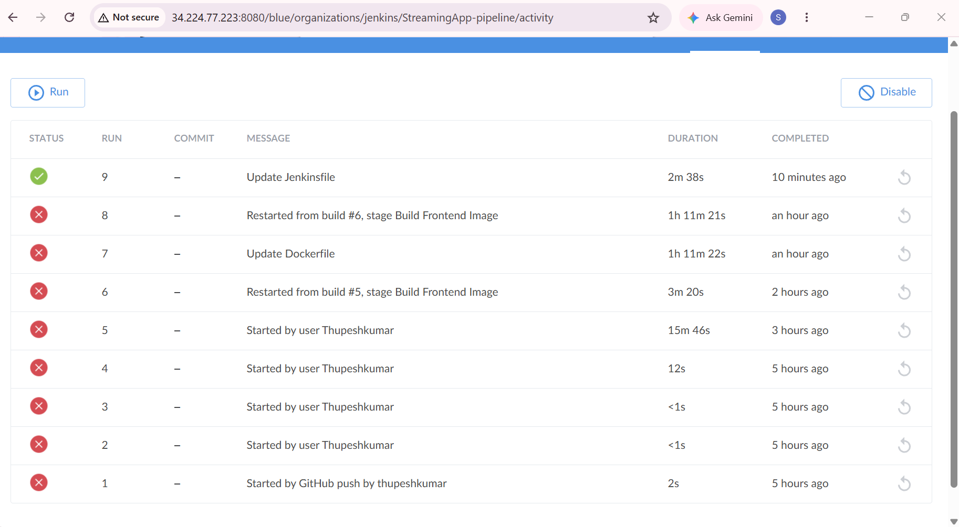
After so much Troubleshooting got the cleanest CI/CD Pipeline finally:
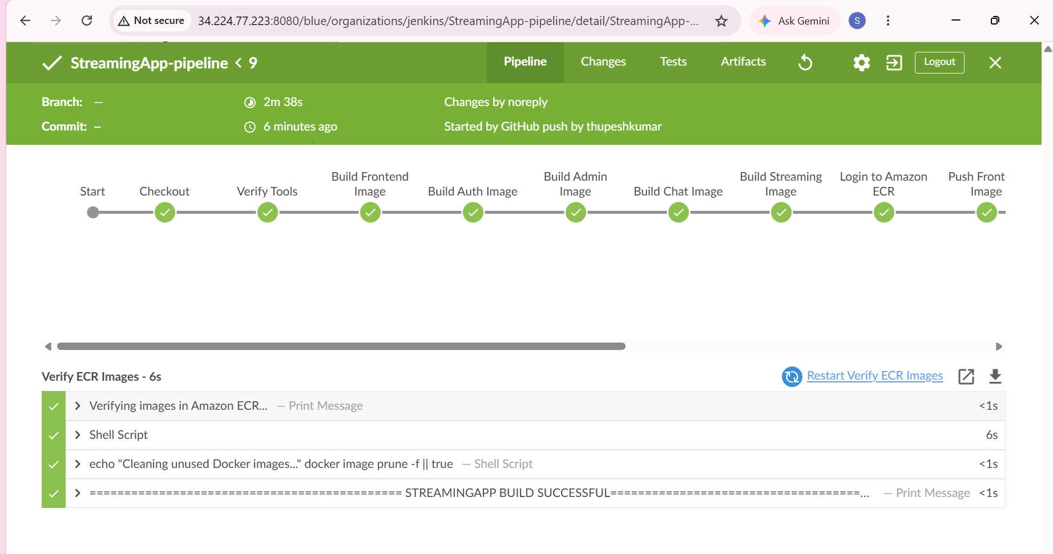
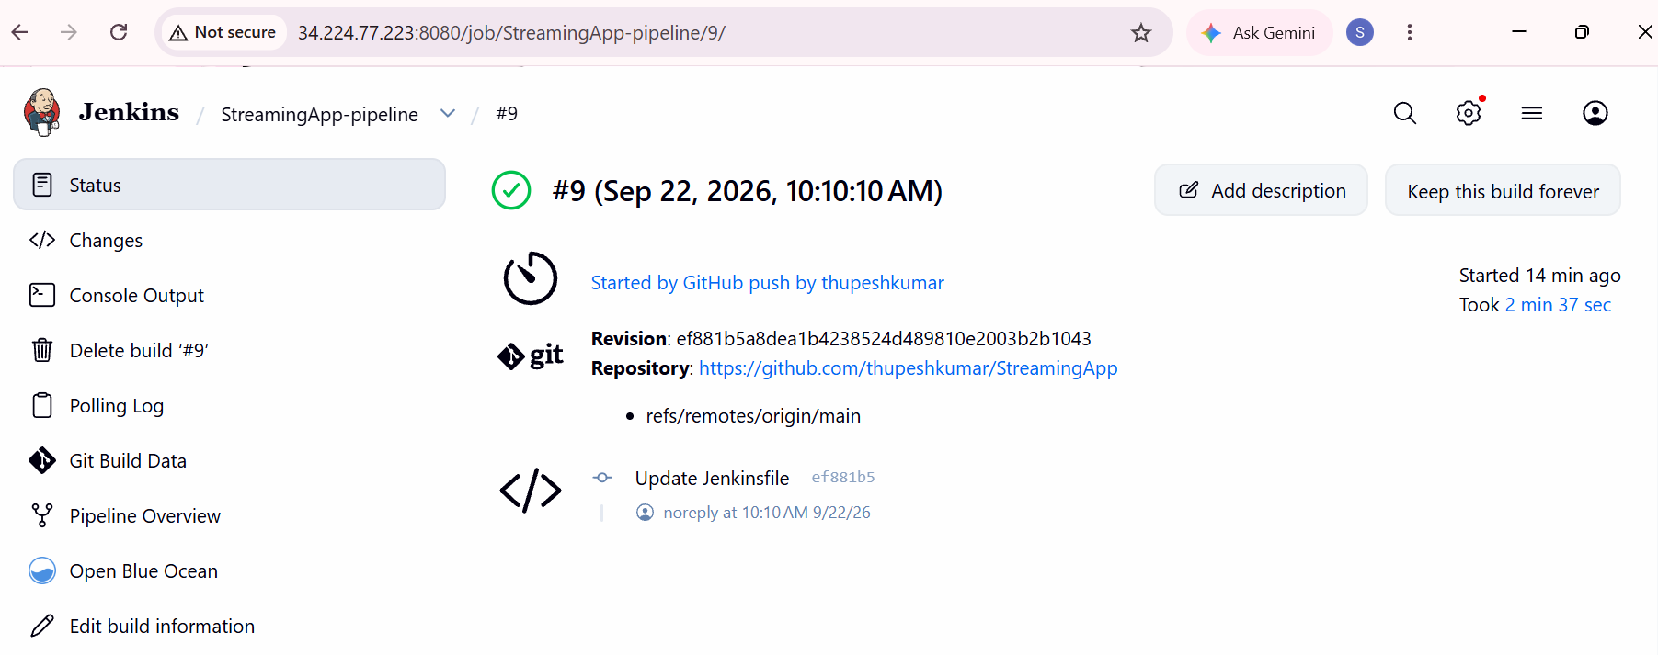

Common Pitfalls
❌ AccessDeniedException → IAM user missing ECR permissions
❌ no basic auth credentials → forgot login step
❌ repository not found → repo name mismatch
❌ Depreciated Versions of dependencies, mismatch with the latest runtime

Now I have to deploy these images on Kubernetes (EKS) using Helm. Let's start!

☸️ PHASE 5: Deployment on Kubernetes (killercoda) with Helm
Verify Cluster Access
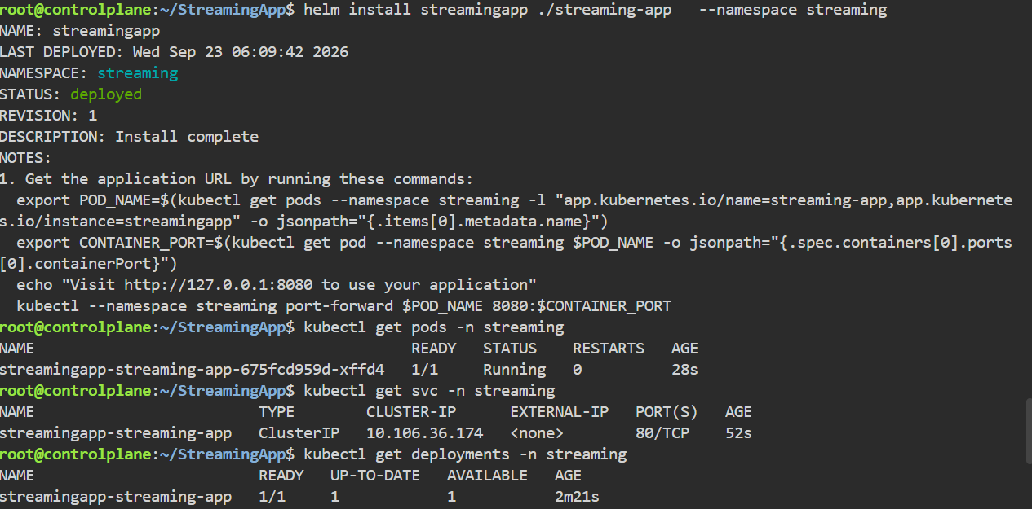

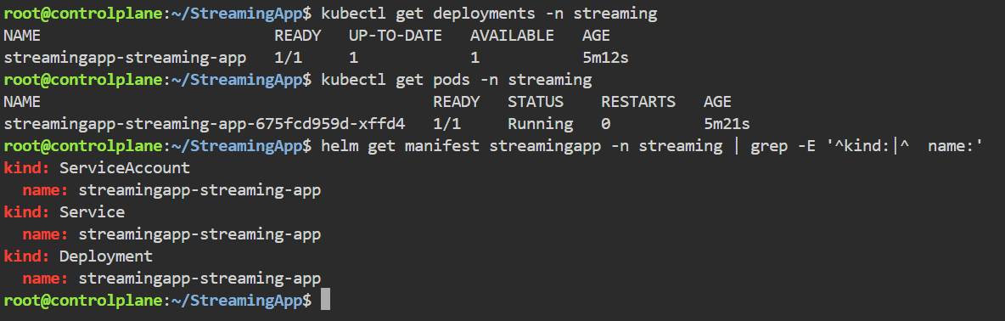
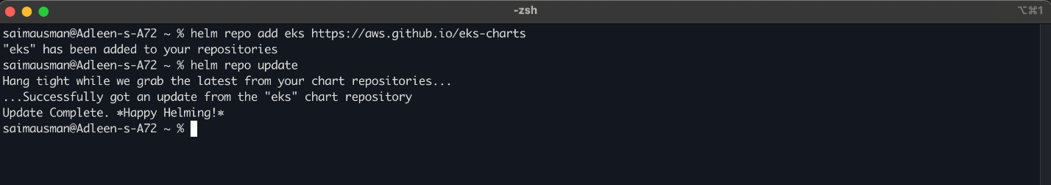

🔹 5.2 Create/Updat Helm Charts
helm upgrade --install streamingapp charts/streamingapp \
--namespace streamingapp \
--create-namespace \
--set global.imageTag="$IMAGE_TAG" \
--set services.frontend.image.repository="$ECR_REGISTRY/streamingapp/frontend" \
--set services.auth.image.repository="$ECR_REGISTRY/streamingapp/auth" \
--set services.streaming.image.repository="$ECR_REGISTRY/streamingapp/streaming" \
--set services.admin.image.repository="$ECR_REGISTRY/streamingapp/admin" \
--set services.chat.image.repository="$ECR_REGISTRY/streamingapp/chat" \
--set secrets.jwtSecret="replace-with-a-strong-secret" \
--set aws.region="$AWS_REGION" \
--set aws.s3Bucket="sam-s3-bucket" \
--set clientUrls=""
Edit if needed:
- values.yaml
- deployment.yaml
- service.yaml
Check the names of ECR images. Verify all names and values are correct
helm repo update
kubectl get pods

Helm does:
- Install the applications on Kubernetes in few commands
- Manage releases
- Upgrade/rollback apps
For the Infrastructure setup automation, we can use Terraform

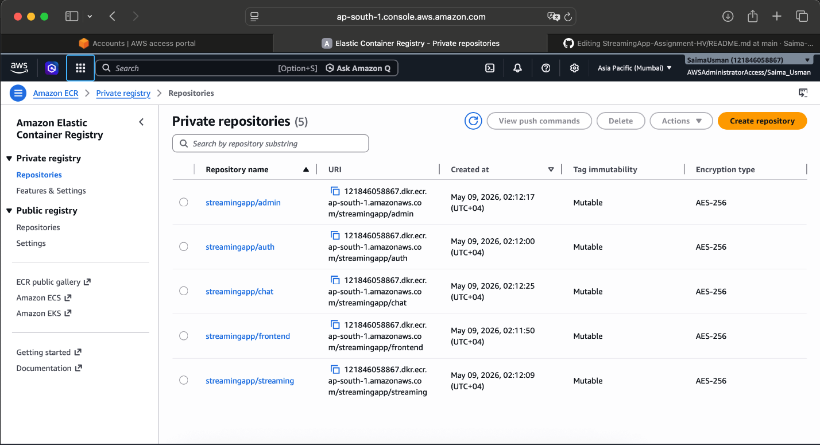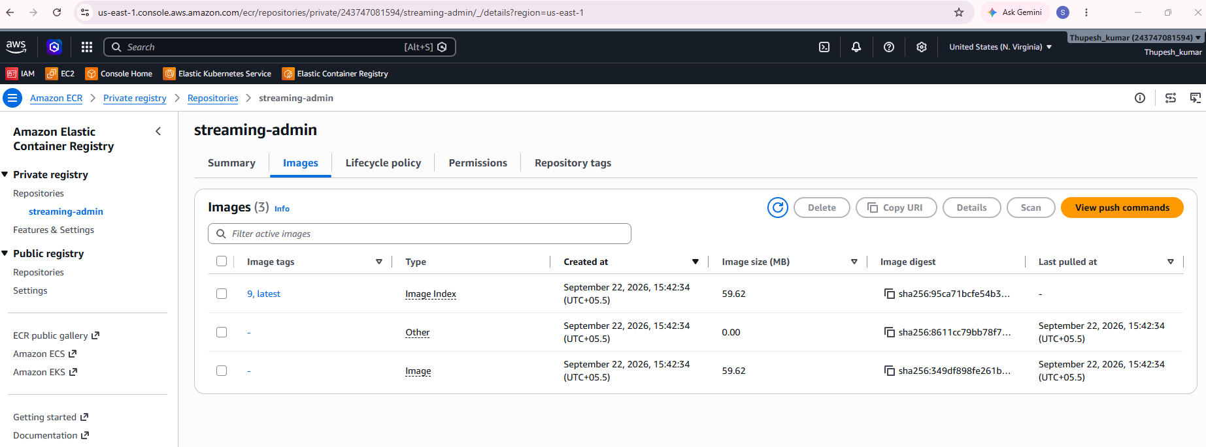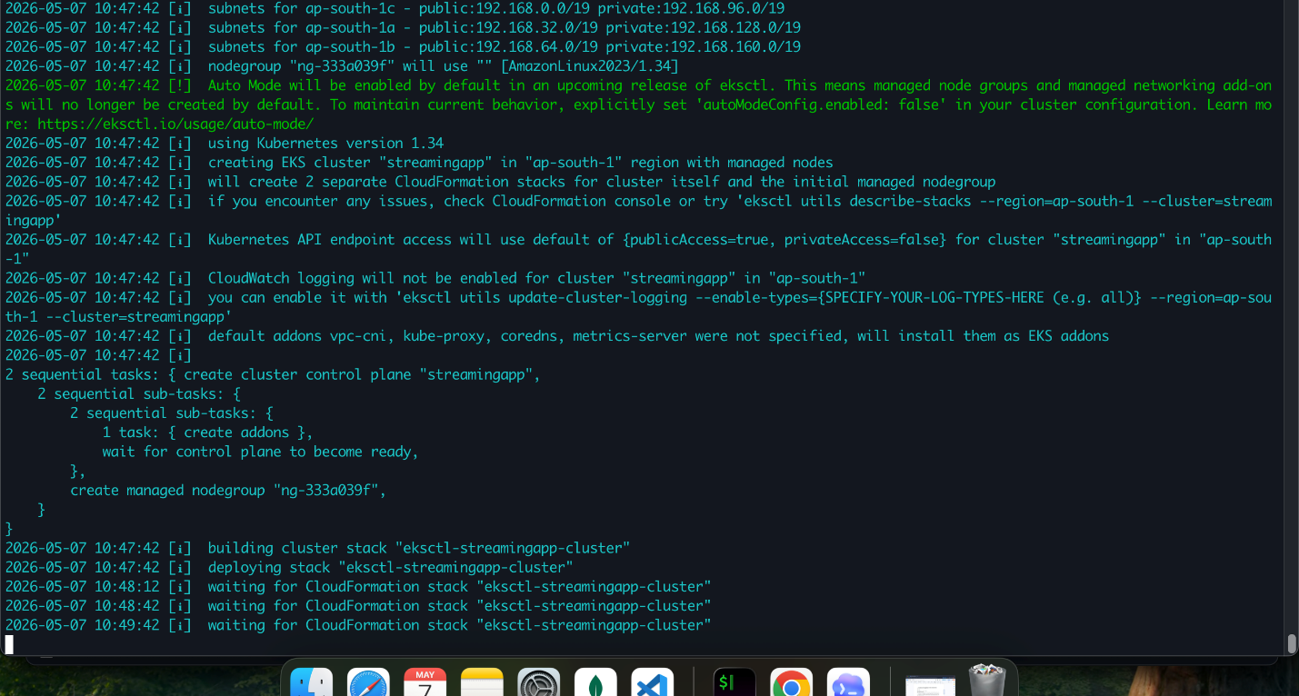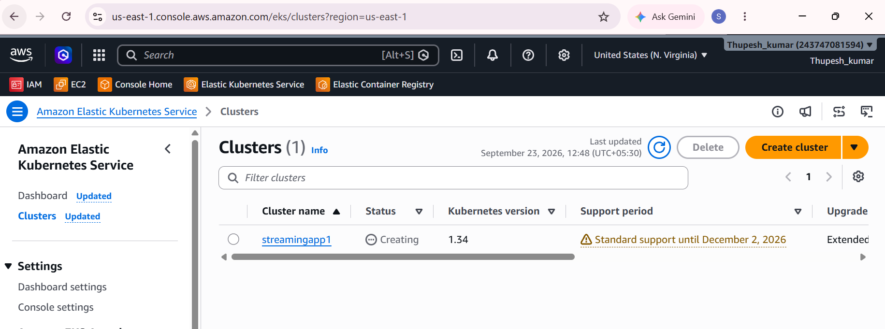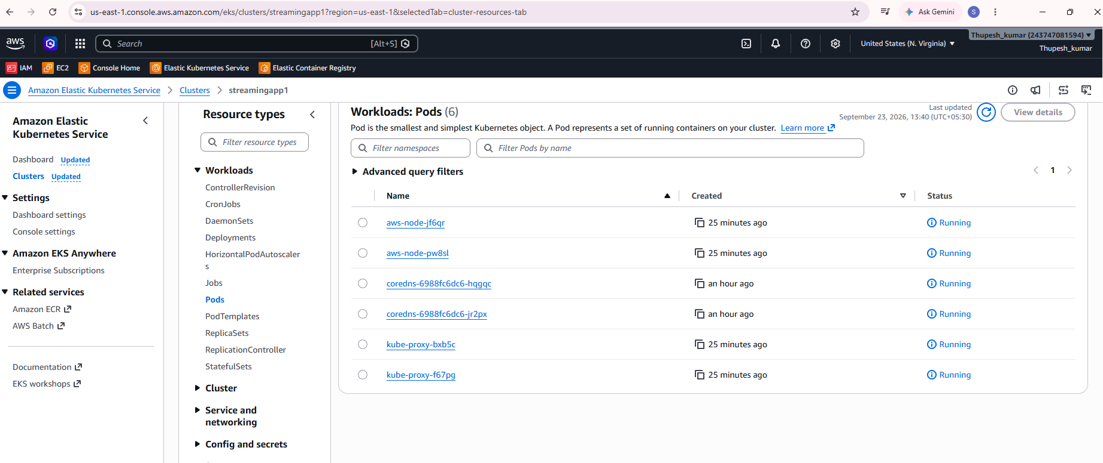
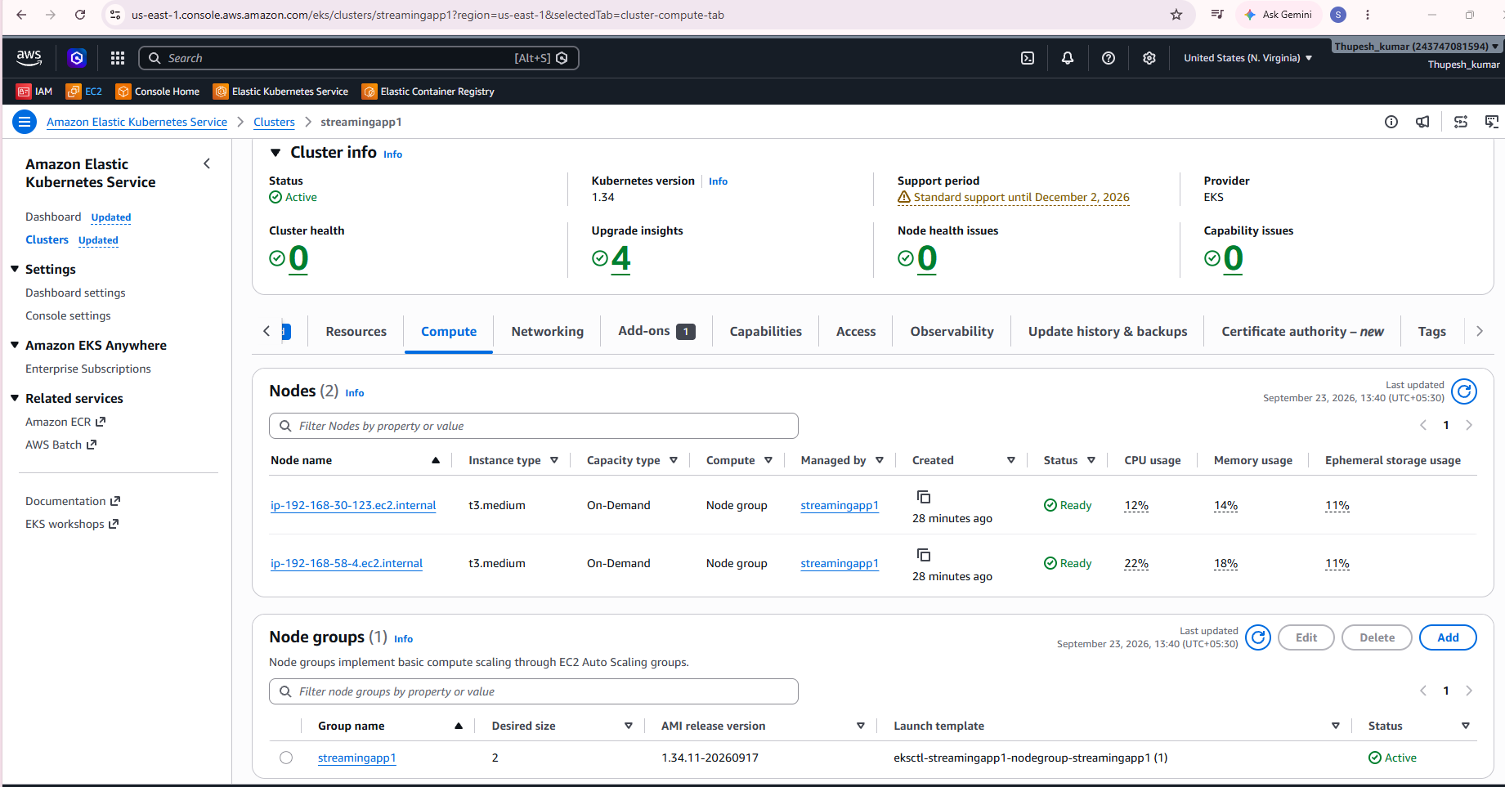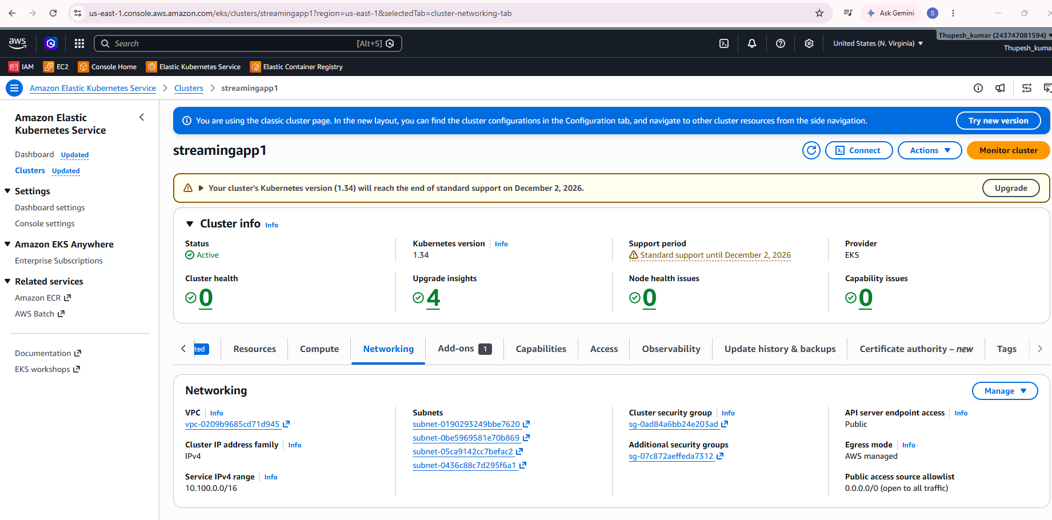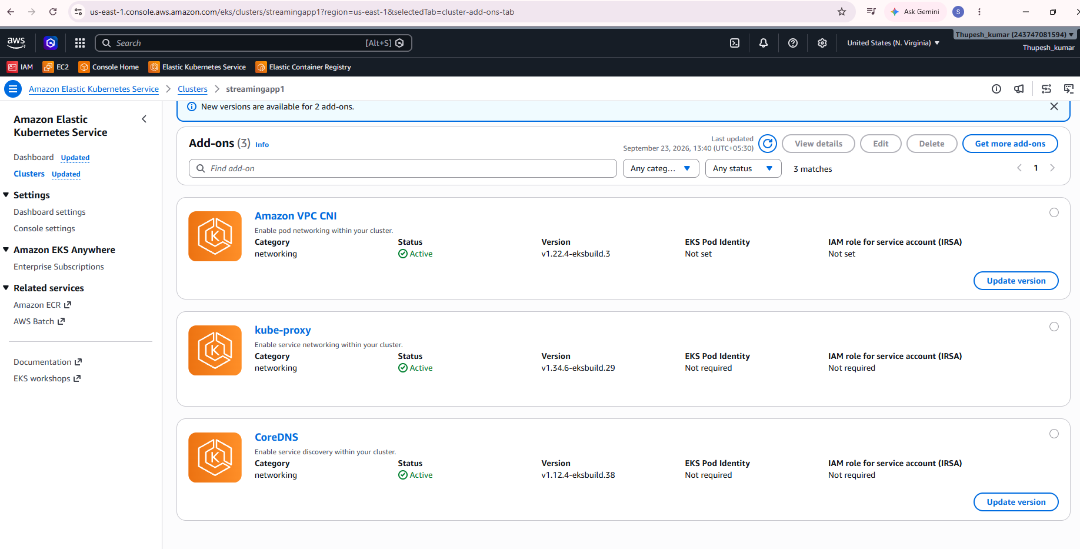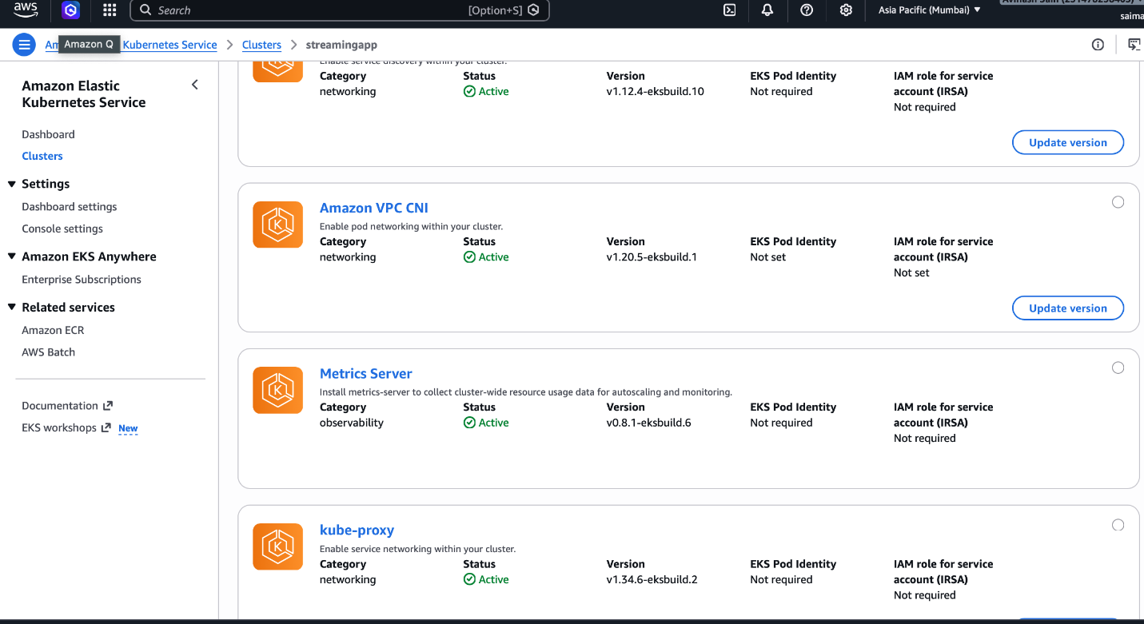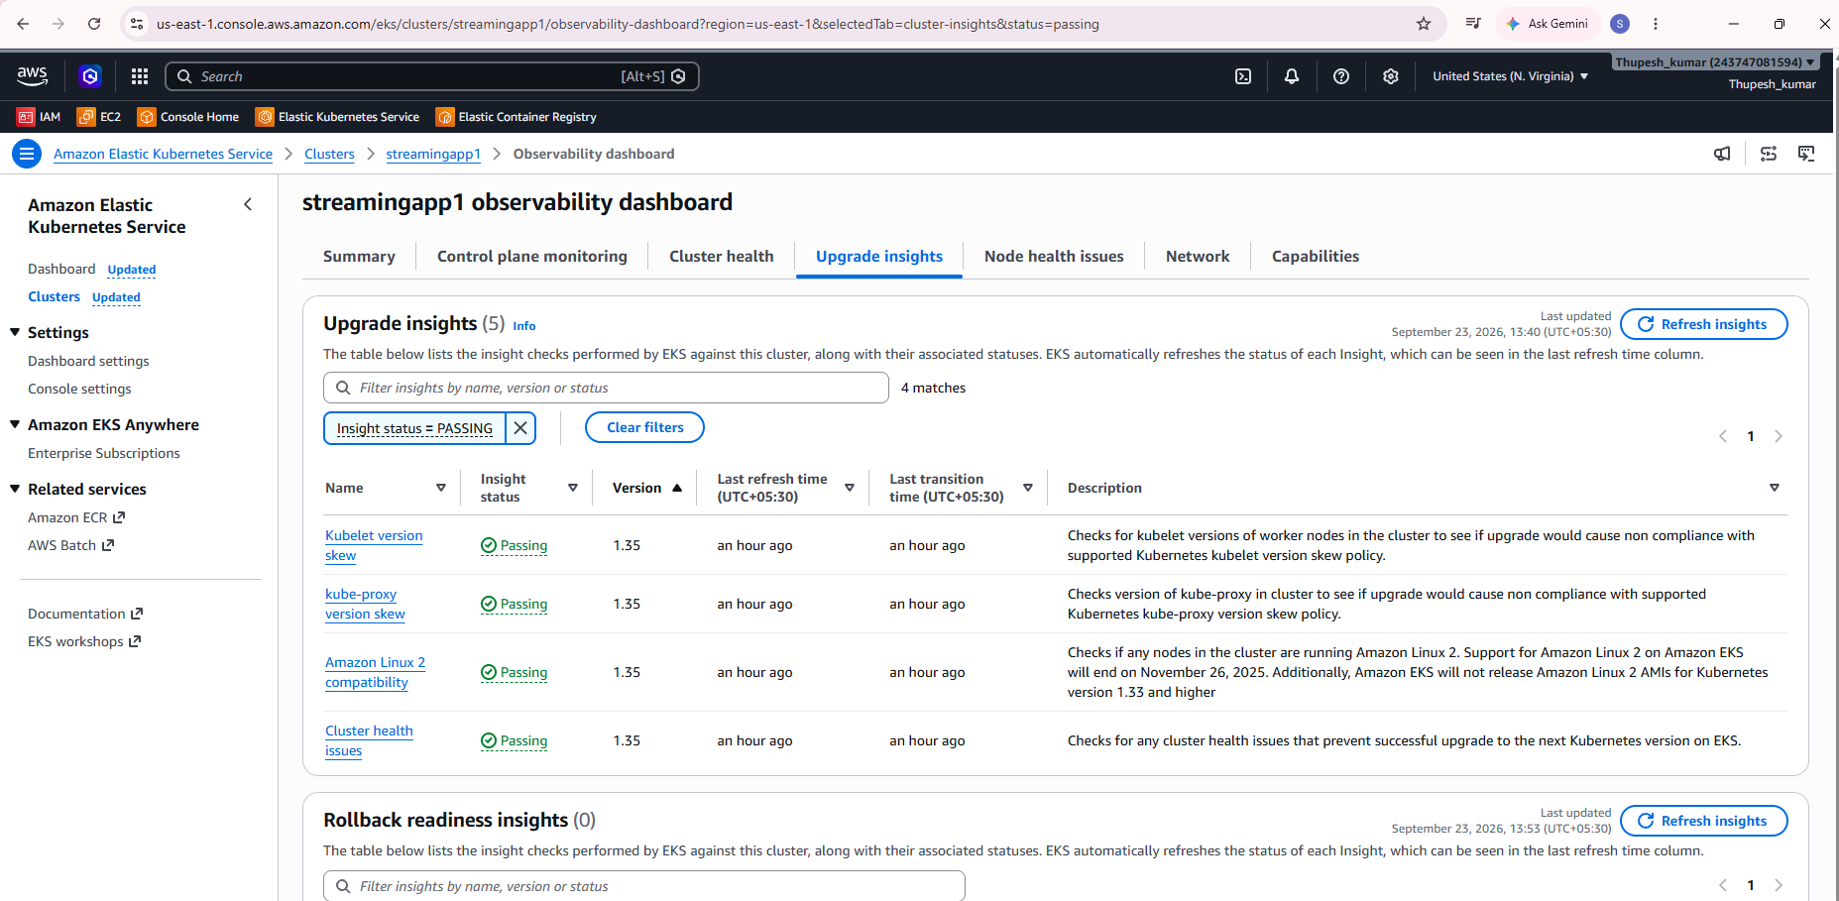

🔹 5.2 S3 Storage
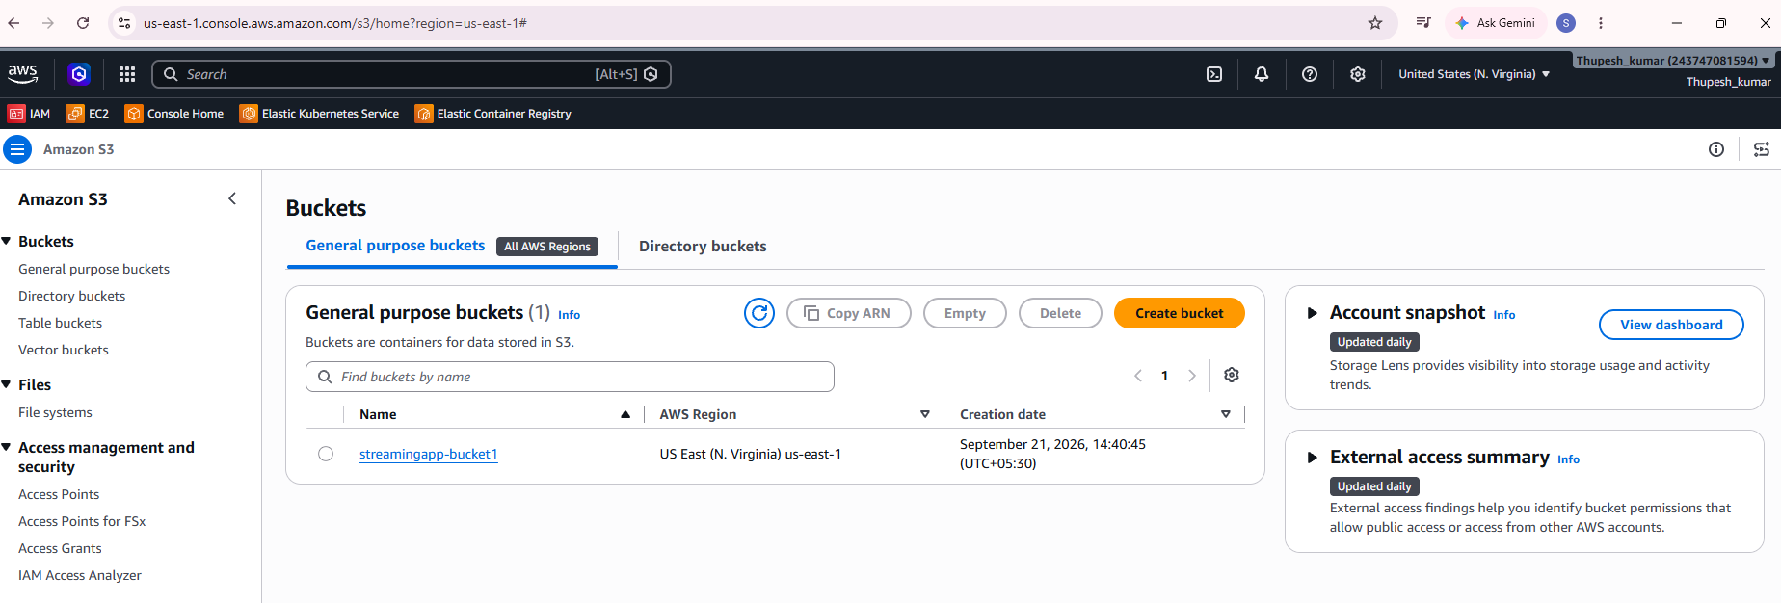
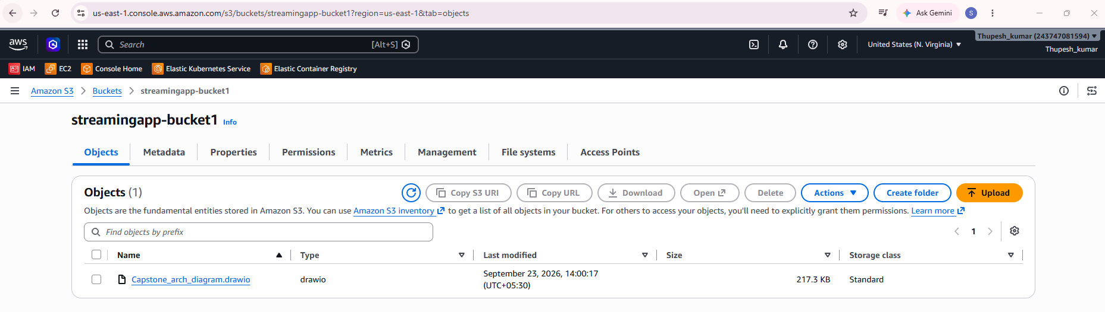

🔹 5.3 Check Rollout
kubectl get pods -n streamingapp
kubectl get ingress -n streamingapp
kubectl rollout status deployment/streamingapp-streamingapp-frontend -n streamingapp

📊 PHASE 6: Monitoring & Logging
by Amazon CloudWatch
Enable logging
Enable CloudWatch Container Insights or the Amazon CloudWatch Observability add-on for EKS:
- EKS → CloudWatch Logs
- EC2 → CloudWatch agent
aws eks create-addon \
--cluster-name streamingapp1 \
--addon-name amazon-cloudwatch-observability \
--region "$AWS_REGION"
Metrics
- CPU
- Memory
- Pod scaling

Recommended alarms:
- ALB target 5xx count > 0 for 5 minutes
- Pod restart count > 3 in 10 minutes
- CPU > 70 percent for app deployments
- Memory > 80 percent for app deployments
- MongoDB PVC usage > 80 percent if using the demo in-cluster MongoDB
All Jenkins Jobs (CI/CD) are done successfully!! 👍
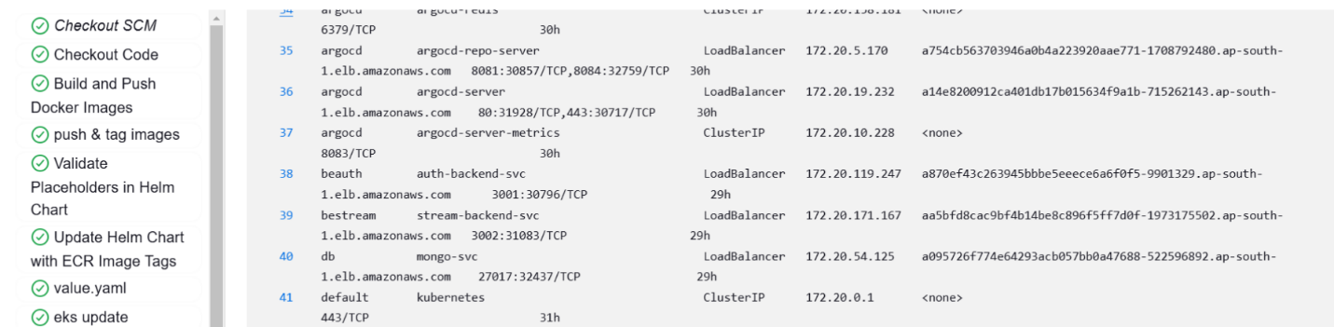

🔔 PHASE 7: ChatOps
Step 1: Create the AWS SNS Topics
First, create two Amazon SNS (Simple Notification Service) topics: one for successful deployments and one for failures.
# 1. Create a topic for Deployment Failures
aws sns create-topic --name streamingapp-deployment-failures --region us-east-1
# 2. Create a topic for Deployment Successes
aws sns create-topic --name streamingapp-deployment-successes --region us-east-1
by Amazon SNS (Simple Notification Service)
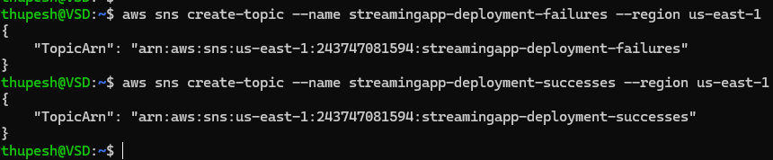
Steps:
- Create SNS Topic
- Subscribe (Email / Slack Webhook)
- Trigger from Jenkins:
post {
success {
sh '''
if [ -n "${SNS_TOPIC_ARN:-}" ]; then
aws sns publish --topic-arn "$SNS_TOPIC_ARN" --message "Streaming app deployment succeeded: $JOB_NAME #$BUILD_NUMBER ($IMAGE_TAG)"
fi
'''
}
failure {
sh '''
if [ -n "${SNS_TOPIC_ARN:-}" ]; then
aws sns publish --topic-arn "$SNS_TOPIC_ARN" --message "Streaming app deployment failed: $JOB_NAME #$BUILD_NUMBER"
fi
'''
}

Create an SNS topic:
aws sns create-topic --name streamingapp-deployments --region "$AWS_REGION"
Set SNS_TOPIC_ARN in Jenkins. The included Jenkinsfile publishes deployment success/failure messages to that topic.

To send SNS messages to Slack, configure AWS Chatbot / Amazon Q Developer in chat applications:

Slack Integration
Steps:
- Connect your Slack workspace.
- Create a channel configuration.
- Attach the streamingapp-deployments SNS topic.
- Allow the channel role to read CloudWatch/SNS notifications.
